Requirements Specification for

DRI Intelligent Map

**Prepared By:**

**Jack Rathbone**

**Ibrahim Ganidagli**

**Dan Atkinson**

**Emily Brown**

**Hetu Lu**

**1 – Introduction**

**1.1 - Overview and justification (purpose):**

The proposed system of the Intelligent map is designed to benefit the staff, patients and visitors who visit the Doncaster Royal Infirmary (DRI). The justification for the new system is due to the mix of old and new buildings that populate the site, it can become incredibly difficult to navigate quickly and effectively. This can pose a substantial problem for staff, patients and visitors of the hospital as getting to the right place at the right time can literally mean life or death. Therefore, the benefit of an easy to use Intelligent Map cannot be understated. The current system ( a static map) is much harder to update when new buildings, wards or clinics open up, this can pose an issue for temporary or mobile clinics such as COVID-19 testing sites which move around on a regular basis. The current static map also doesn’t provide the most efficient route to get to where the user wants to go which slows down movement throughout the hospital and increases the number of patients who show up late or miss appointments. There is also the need to get quick answers to common questions within the map in an accessible way.

The new system will add interactivity to the map and display the room information in a much less cluttered way that is easier to understand. Our map will also include a navigation system to plot routes between two locations, this has the benefit of removing the issue of the hospital being hard to navigate since the map will do the hard work for the user. This would greatly help new visitors and patients who haven’t been to the hospital before. Our system will also include Artificial Intelligence which can navigate the map and provide location information to the user using a text or voice input from the user. This benefits people who are not as competent with technology such as the elderly. The new system will also benefit staff members since they will be able to easily update the map whenever they need to change the location of a room.

This document outlines the scope and description in section 1, The functional and nonfunctional requirements as well as the potential risks are included in section 2. In section 3, the project development approach as well as the proposed schedule are found.

**1.2 - Project scope:**

This project is a 2D map showing the layout of the Doncaster Royal Infirmary. It will display the names of different rooms and, for those on the upper floors there will be a table containing the name of every room. A specific set of information can be stored about each room, this information is the opening times, facilities and products sold (if applicable). The map is able to plot navigation routes between two locations on it and the system will provide a visual representation of the route along with details such as steps to take, distance and time taken. The system can only plot routes between different buildings and the major corridors on the ground floor. When navigating to a room on an upper floor, the user will be directed to that building and a message will detail what floor of that building the room is on. Audio messages will play, describing the steps of the route. The user has two choices of input to the system, text from a keyboard or voice from a microphone. The system will feature an AI that can plot routes and respond to questions. It will only be able to answer the top 10 commonly asked questions about hospitals using the information provided about the DRI. The map will be able to be updated by changing the building location associated with a given room. There will be a security system that only allows staff members to change the map.

The purpose of this project is helping users know how to get to their destination. The overall goal should benefit all the users like staff, visitors, especially patients.

Goals:

* Display interactive map
* Navigate between two locations with audio and visual feedback
* Create AI model that can correctly answer questions and provide an accessible way to navigate
* Allow map to be easily updated for any situation

User base:

* Staffs
* Visitors
* patients
* Anyone who is at the hospital that has a mobile phone or laptop

Future versions:

* Turning 2D to 3D to show vertical layout of buildings
* Include full interior maps so the exact layout of different corridors can be represented on the map
* add street view so the user can see the surroundings in the same way as if they were really there
* More intelligent AI (can answer more and more complex questions, even talking to the users) able to answer more than the top 10 most common questions

* Automatic map updating so changes can be scheduled for specific times or in different circumstances

**1.3 - System description:**

The project will take the form of a web application that can be viewed on any modern browser and will be responsive so that it can work on any device e.g. mobile devices. The project will be a map of the hospital, this will be displayed to the user and can be interacted with in various ways including being able to zoom in on different sections of the map and being able to drag the map to view sections outside of the screen boundary. The main use case of our system is for when a visitor or patient of the hospital is unsure of how to get somewhere, they can then use the map to find the correct route and they can also get answers to any queries they might have about the location. There is also the use case of a staff member who might need to access the map to edit certain details such as when a room is moved or a new area is set up. The map will display labels for each room on the corresponding building as well as a table listing all the rooms on the upper floors. When clicking on the rooms, the user can view different information about each area such as the opening times and facilities. This will require a database that stores all this information which will be fetched by the web browser. The map allows the user to enter their location by way of clicking on the location where they are and placing a pin. The system lets the user plot a route using a destination and their starting location, which can be manually selected or obtained using the placed pin. There are visual and audio effects that guide the user on the calculated route. A visual line will be drawn along the pathways of the map to show the route along with a description of the steps that make up the route, there will also be an estimated distance and time taken calculated for the route which will be outputted to the user.. The user can tick off the steps as they travel and this will update the visual line. Audio Lines will be played describing the route as the user works through the different steps. The map also needs to be able to be updated, this means that the location of any room can be changed to a different area/building in case such a situation where this would be required arises. This is done by updating the database that stores all the room information. The system for updating the map needs to be restricted to staff members only so there will need to be some kind of authorisation and authentication to ensure this system is secure. The map also needs to be accessible to different groups of people so for any type of input there will also be the option to use their device’s microphone and there will be a speech-to-text system in place that converts this to a text input. The web application will also include an AI that can answer the users’ questions and plot navigation routes. The AI has access to the information about each room stored in the database and can use this to answer questions. The AI can also access the location of the pin when being asked about how to get to certain locations.

The existing system is a static map which shows the layout of the different buildings and labels of where each room is supposed to be. The map is fairly cluttered with information and the layout is confusing to follow which makes it hard to navigate. It isn’t very accessible since there are no audio elements to the map. It isn’t interactive and if a room needs to change location then a whole new map image needs to be created so it’s very difficult to maintain. There is also no AI system in the current solution and the details of the different rooms can only be found on a separate website.

The most similar system we have researched is Google Maps. This system operates on a much larger scale than ours however the basic navigation functionality is the same. The maps can be interacted with and there are labels for the different buildings which can be clicked on for more information. This system also has the pin functionality and is very accessible with speech-to-text options. The most useful features of this system are the route planning system where the user can specify start and end points and the building label functionality where details of each area can be displayed as an overlay to the map. This system has many features which aren’t really useful in our context, these include being able to add stops along a route which isn’t necessary on our scale and the system that allows the user to leave reviews for different locations wouldn’t have much of a benefit in our project.

**2 – Solution Requirements:**

**2.1 - Functional requirements:**

| ID and Title | FR1 - Application provides interactive Map |
| --- | --- |
| Description | When loading the application, the user is presented with an interactive map of the DRI, this shows the layout of the different buildings and the pathways connecting them. There are also labels of the various rooms and buildings including a list of those rooms on the upper floors of the hospital. |
| Priority | High |
| MuShCo | Must have |
| Dependencies | n/a |
| Expected Result | The correct map is displayed when the user connects to the web page |
| Exception Handling | The map image could fail to load  There could be an error if the browser is unable to fetch the stored rooms from a database |

| ID and Title | FR1.1 - Map can be scrolled and zoomed |
| --- | --- |
| Description | The user can zoom in and out on the map using either the scroll wheel or the displayed buttons, the user can also pan across the map by dragging |
| Priority | High |
| MuShCo | Should have |
| Dependencies | FR1 |
| Expected Result | The map interacts correctly to the users input when they drag, click or scroll |
| Exception Handling | The user could try to zoom in or out past the maximum or minimum threshold  The user could try to pan past the edge of the map outside of the hospital |

| ID and Title | FR1.2 - Room labels can be clicked for extra information |
| --- | --- |
| Description | When clicking on any of the rooms on the map a window appears with information about these areas. This information includes:   * Opening times * Facilities * Products sold (if applicable) |
| Priority | Medium |
| MuShCo | Should have |
| Dependencies | FR1 |
| Expected Result | When clicking on a room, the correct room with its corresponding information is displayed. This is done by querying a database |
| Exception Handling | Database could return a room not found error if not set up correctly |

| ID and Title | FR1.3 - Users can designate a position on the map as their location, this places a pin on that position that can be used for navigation. |
| --- | --- |
| Description | The user can hold click on the map at any point, this causes a pin to appear at that position. The user can change the position of the pin as often as they want. |
| Priority | High |
| MuShCo | Must have |
| Dependencies | FR1 |
| Expected Result | The pin is placed in the correct position whenever the user hold clicks on the map |
| Exception Handling | The user could try to place the pin on an area outside of the map |

| ID and Title | FR1.4 - Room table for multiple floors |
| --- | --- |
| Description | There is a table that contains a list of every room in the DRI grouped by building and floor. Clicking on rooms in this table is an alternative way to select them instead of clicking their label on the map. This is the only way to select rooms on the upper floors of the hospital since they won’t be displayed on the map by default |
| Priority | High |
| MuShCo | Should have |
| Dependencies | FR1 |
| Expected Result | A table is displayed which lists every room and when clicking on one it correctly selects that room in the correct location on the map |
| Exception Handling | Could be a connection error if unable to fetch list of rooms from the server, there would needs to be an error message displayed in this scenario. |

| ID and Title | FR2 - Navigation system |
| --- | --- |
| Description | Visual routing between two positions on the map |
| Priority | High |
| MuShCo | Must have (audio - should have) |
| Dependencies | FR1 |
| Expected Result | Directions available between any 2 locations on the map. A visual route line is plotted between the two points on the map. A list of steps for how to get between the two points is displayed and the user can tick these steps off as they travel towards the destinations and this updates the visual route accordingly. The estimated distance and time taken for the route will also be displayed for each step. |
| Exception Handling | You cannot navigate to outside of the map bounds. You can only go across walkways, not across open space. |

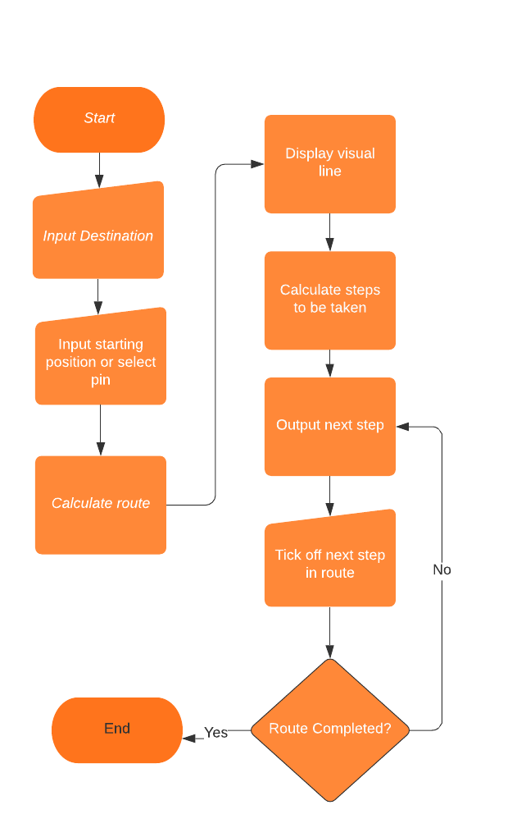

| ID and Title | FR2.1 - Audio for the navigation system |
| --- | --- |
| Description | Audio queues for each step of the directions. When the user ticks off a step, an audio voice is played describing the next step |
| Priority | Medium |
| MuShCo | Should have |
| Dependencies | FR1, FR2 |
| Expected Result | Once you tell the system a step is completed, the audio will guide you through the next step. The audio will also immediately play the first step of the route |
| Exception Handling | Null |

| ID and Title | FR2.2 - Input to the navigation system |
| --- | --- |
| Description | The user is presented with two input boxes, one for the start position and one for the destination. The user can select the pin, if placed, for the starting position. This is then used to create the route. |
| Priority | High |
| MuShCo | Must have |
| Dependencies | FR1, FR2, FR1.3 |
| Expected Result | There are two input boxes for the user to use to navigate |
| Exception Handling | The user could enter a location that doesn’t exist on the map so a not found message would need to be displayed |

| ID and Title | FR2.3 - Voice input to the navigation system |
| --- | --- |
| Description | For both input boxes the user has the option to use their microphone to say what they want to input so that they can interact with the map in a more accessible way |
| Priority | Low |
| MuShCo | Could have |
| Dependencies | FR2.2 |
| Expected Result | The user can say what they want to input and this is correctly translated into the navigation system |
| Exception Handling | The user might say nothing so eventually the system needs to stop listening  The user might say something that the software can’t recognise so a try again message needs to be displayed if this happens |

| ID and Title | FR3 - AI |
| --- | --- |
| Description | There will be an AI that the user can send questions to. The AI will be able to answer the top 10 commonly asked questions about hospitals as well as general navigation questions. The AI will use the database of room information to answer questions. |
| Priority | High |
| MuShCo | Must have |
| Dependencies | n/a |
| Expected Result | Feels as close to talking to a real person as possible. AI will accurately answer questions. |
| Exception Handling | When the AI is asked a question it can’t classify it needs to send a message saying it doesn’t understand |

| ID and Title | FR3.1 - AI for navigation |
| --- | --- |
| Description | The AI will be able to answer navigation based questions and plot a route using the navigation system according to the query. The AI will also understand certain context such as “from here” meaning from the users current location e.g. the pin |
| Priority | High |
| MuShCo | Must have |
| Dependencies | FR1, FR2, FR1.3, FR3 |
| Expected Result | AI will correctly activate the navigation system using the correct starting location and destination |
| Exception Handling | The AI may try to navigate to a room that doesn’t exist or not recognise the question, an error message must be displayed in either case |

| ID and Title | FR3.2 - AI voice Input |
| --- | --- |
| Description | The user is able to ask the AI questions using their microphone instead of typing in a text input |
| Priority | Low |
| MuShCo | Could have |
| Dependencies | FR3 |
| Expected Result | Voice input is correctly translated and the AI provides a response to the question |
| Exception Handling | User may say nothing or something the system doesn’t recognise, so a try again message needs to be displayed |

| ID and Title | FR4 - Updating the map |
| --- | --- |
| Description | The room labels on the map shall be able to be updated depending on if the room has been moved to a different area/building |
| Priority | High |
| MuShCo | Must have |
| Dependencies | FR1, FR5 |
| Expected Result | Room labels should be correctly updated on the map |
| Exception Handling | In the case where two rooms are assigned to one area or one room assigned to two areas, an error message should be displayed and the update should be denied |

| ID and Title | FR4.1 - Update Menu |
| --- | --- |
| Description | There needs to be a staff-only menu that allows the location of rooms to be changed. This would require a staff login with username and password. Once unlocked, there is a list of each building area and the room that is set for it. This can then be changed and saved to the database |
| Priority | High |
| MuShCo | Must have |
| Dependencies | FR1, FR5, FR4 |
| Expected Result | Update menu correctly updates the map and only staff member can use it |
| Exception Handling | In the case where two rooms are assigned to one area or one room assigned to two areas, an error message should be displayed and the update should be denied |

| ID and Title | FR4.2 - Update Menu Login system |
| --- | --- |
| Description | To access the update menu, a staff username and password is required. Once this is validated, the update menu is shown. Once staff Users are logged in, they have the option to create new staff member accounts |
| Priority | Medium |
| MuShCo | Should have |
| Dependencies | FR5, FR4.1 |
| Expected Result | Staff members can successfully log in, non staff members cannot. Staff members can create new accounts |
| Exception Handling | New account could be created with a username that is already taken  User could try to login with invalid credentials, in this case a reject message needs to be displayed |

| ID and Title | FR5 - Information database |
| --- | --- |
| Description | There will be a back-end database that stores the rooms for each associated building and certain information about each room e.g. opening times |
| Priority | High |
| MuShCo | Should have |
| Dependencies | N/A |
| Expected Result | The database should function with the volume of information needed and provide the correct response into any query |
| Exception Handling | When querying for records that don’t exist a correct error message must be sent |

**2.2 - Non-functional requirements:**

| Type | Performance requirement |
| --- | --- |
| Metrics | Route calculations for navigation on the map need to be completed in less than 5 seconds |
| Constraints | map needs to run within the browser so will rely on the clients hardware. Map is interactive so visual rendering of the route will need to be redrawn whenever the map view moves |

| Type | Performance requirement |
| --- | --- |
| Metrics | AI needs to classify and respond to questions in less than 3 seconds |
| Constraints | AI model needs to be ran in a separate server. |

| Type | Security requirement |
| --- | --- |
| Metrics | Unauthorised users should be unable to access the menu for updating the map |
| Security | Only users who have a valid staff username and password should be able to login to the update menu |
| Constraints | Designing our own authentication and encryption systems is outside the scope of the problem so it is necessary to use an already developed framework |

| Type | Usability requirement |
| --- | --- |
| Metrics | Users should be able to plot an intended route in the most efficient way possible. This can be measured by the number of clicks it takes to set up a navigation route |
| Constraints | Map needs to display all the required information so not everything can be displayed at the same time. map needs to be adaptive to mobile screen sizes and layouts. |

| Type | Usability requirement |
| --- | --- |
| Metrics | System should be accessible to different groups of people. There shouldn’t be any groups of people who are unable to interact with the system |
| Constraints | System runs in a web browser so the only methods of output are visual and audio |

**2.3 –Risks and Issues:**

In this risk assessment, we intend to identify any threats to the project’s objectives and to outline mitigation strategies. We will discuss limitations and uncertainties we face, and their likelihood opposed to the impact they would cause. Finally, we will indicate the order in which we will prioritise addressing these risks.

One potential performance risk of the application is the distances between locations being inaccurate. This could lead to estimated arrival times being inaccurate, which would likely cause users to be late to appointments and meetings. The main issue leading to this risk is the lack of resources to build the map from as we cannot currently access the site in person. To minimise this risk, we intend to interact closely with the client to ensure measurements are correct, and to optimise the use of other online resources and mapping technology such as Google Maps. This risk is of high priority as the loss and likelihood are both high.

Another potential performance risk is not having a high enough level of artificial intelligence. We must ensure that the AI is trained to a high enough ability for the functionality we require. To mitigate this issue, we aim to encourage the user to ask questions that the AI is able to respond to correctly and effectively. For example, the AI could suggest how to phrase questions. Moreover, the AI should be able to communicate that it does not understand what it is being asked when required. This problem is not unlikely, but the potential loss is low as we will be able to adapt the application for it, so this risk is of medium priority.

In the event of a server malfunction, we could have times where the database is inaccessible. This is a potential limitation of any software we choose to use. The risk is unavoidable, but as previously, the severity of its impact on the user can be reduced by adapting the app to cope with this. For this reason, the risk is of medium priority. We will allow the user to save previous sets of directions, which can be stored offline. This way, even if the map was not functioning properly, users can still access the information they regularly need. When choosing a server to host our database, we will prioritise the software’s reliability and reputation so that this does not happen often. However, we must weigh the benefits against the monetary impact, as investing in expensive software could cause the project to be completed over budget.

While considering the expenses of any systems used, we acknowledge the risk of errors in cost estimation. Fortunately, as we are working in a closed small team, we will have few external costs so this risk is low. The only expense we currently require is server hosting. However, there would be a large negative impact on the project in the unlikely event that it could not be properly funded, so we view this as low-medium priority. We intend to keep track of any expenses in a document and to stay safely within our budget to avoid the risk.

With all applications, there is the risk of the system not being fully accessible to all needs, especially when we are working towards a deadline to have all features completed. This would be of great loss to the application so we will highly prioritise implementing the audio cues for the navigation, as this is the feature we feel is most capable of increasing accessibility needs.

A common schedule-related risk to any project is scope creep. If the stakeholders were to change the project requirements or if a miscommunication occurs, we could have time management conflicts. Due to the nature of the project, this risk is unlikely and of lower priority than other risks. We will ensure that adequate time remains at the end of the project to address any unforeseen issues which may arise.

In summary, under careful review of potential threats, we have decided to prioritise the accuracy of our map proportions, the quality of external software used and the accessibility of our application. We will also address other scheduling, performance and cost risks, but we believe these three risks have the highest loss against uncertainty ratio.

**3 – Project Development**

**3.1 – Development approach**

There are two types of development approaches that can be used for the DRI Intelligent Map system: Agile and Waterfall. The project is broken down into sprints with an agile approach, and at the end of each sprint the program is tested, while there is no going back at the end of each section with a waterfall approach.

| Agile | | Waterfall | |
| --- | --- | --- | --- |
| Advantages | Disadvantages | Advantages | Disadvantages |
| Easy to implement changes at any point. | Multiple stages of the same part of the project may be required in some instances. | Very simple methodology, easy to understand. | Very difficult to edit since at the end of each section, there is no going back. |
| Better project quality since changes can be made according to the client’s opinion. | The project could take longer since there would be numerous sprints. | Shorter project timespan & easier to calculate when the project will be complete. | Risks have to be assessed prior to starting the project. |
| The project becomes more relevant since the focus of the project can constantly be updated when meeting the client. | It’s difficult to calculate an end to the project since the sprints can continue on forever until the client is satisfied, if the requirements are vague. | Since each risk is assessed prior to starting the project, the number of spontaneous problems will be significantly less than an agile approach. | Very strict deadlines attached to the project. |

After careful consideration, the best methodology that can be used for our DRI Intelligent Map is an agile approach. Having individual sprints while executing the technical solution will allow for a more relevant and successful project. Within the agile methodology, there are different types of frameworks, such as:

* Scrum - breaking down projects into individual sprints and focusing on each sprint one at a time.
* Kanban - project is split into to-do lists for visual purposes and sprints can be worked on simultaneously.
* Extreme Programming (XP) - uses intervals and sprints but only for specific types of projects that match its requirements.
* Crystal
* Lean

Conclusively, the type of agile framework that best suits the project is scrum, as it keeps the project in a more organised state, allowing for easier overall project management. From first impressions, Scrum seems to provide the most in the context of the DRI Intelligent Map project.

**3.2 – Project Schedule:** Provide a project schedule, identifying deadlines for key aspects of the project. This can be provided in whatever format you deem most suitable

Our project will have the following deadlines:

* Requirement Spec + Peer evaluation 1 - 4th Nov
* Design Video Presentation + Peer evaluation 2 - 9th Dec
* Test Plan Report + Peer evaluation 3 - 27th Jan
* Product Presentation + User Manual + Peer evaluation 4 - 17th March
* Reflective Report - 28th April
* Product Handover - 29th April

The schedule is also represented as a Gantt chart below: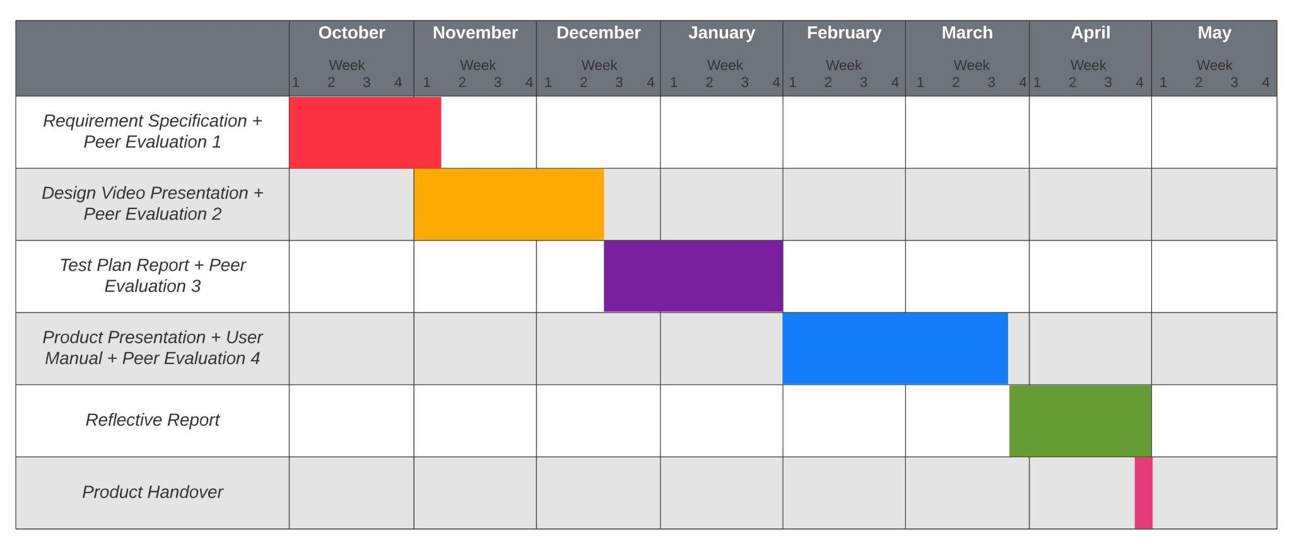

Each part of the project has a set deadline for submission, although for this project we will strive to complete tasks one to two weeks prior to each deadline to ensure that everything matches the requirements and requests of the client, when possible.